Superfast Cornwall – Inclusive Growth
Quotes / Procurement Guidance

It is very important to make sure you provide compliant evidence of your project costs with your application. This will confirm the costs included in your application are accurate (so the correct level of grant may be offered) and help speed up the application process if we don’t have to ask for more information.
There are typically 2 ways to evidence the cost of an item; screenshots of the item on the supplier’s website or a written (e-mailed) quote direct from the supplier. The type of evidence provided depends on the item you are requesting funding towards. For example, if the specific item or service you require is listed on a supplier’s website, then a screenshot of the site is appropriate. However, if you’re seeking a bespoke service from somebody, e.g. a website designer, then a quote will be appropriate.
Whichever approach is required, they will need to contain specific information to be considered compliant as per the examples below.

Screenshot of Supplier’s Website
Take a screenshot on a Windows computer by holding the Windows key, Shift key + S at the same time. The screen will look slightly darker and you’ll notice some crosshairs (like this, +). Move the crosshairs to the top left of the screen, hold down your left mouse button and drag to the bottom left of the screen before letting go of the left button. This will take the screenshot of the selected area. Check your screenshot includes the correct information as shown in the example. Save your screenshot as an image (e.g. jpeg) before attaching to your email to us.

Example of a compliant screenshot with key information shown:
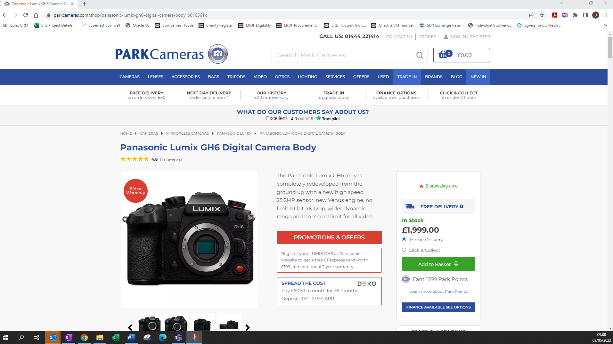
Project description
Total price
Website address
Name of supplier
Date screenshot taken
Full name of item

If the information on the screen is larger than one screenshot, please provide additional screenshots that clearly follow each other (i.e. there are no gaps between the details). For example:
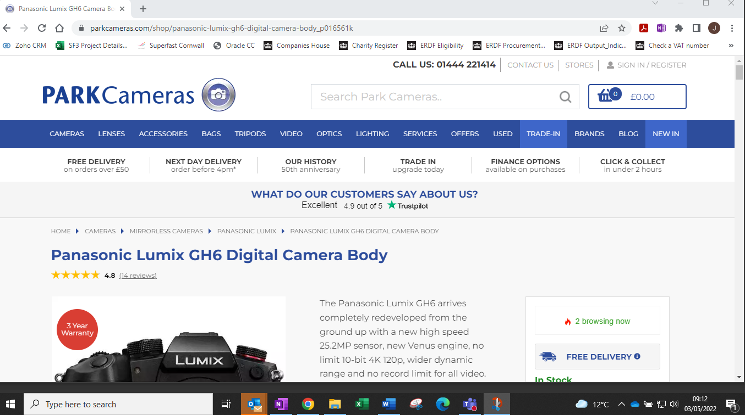 & 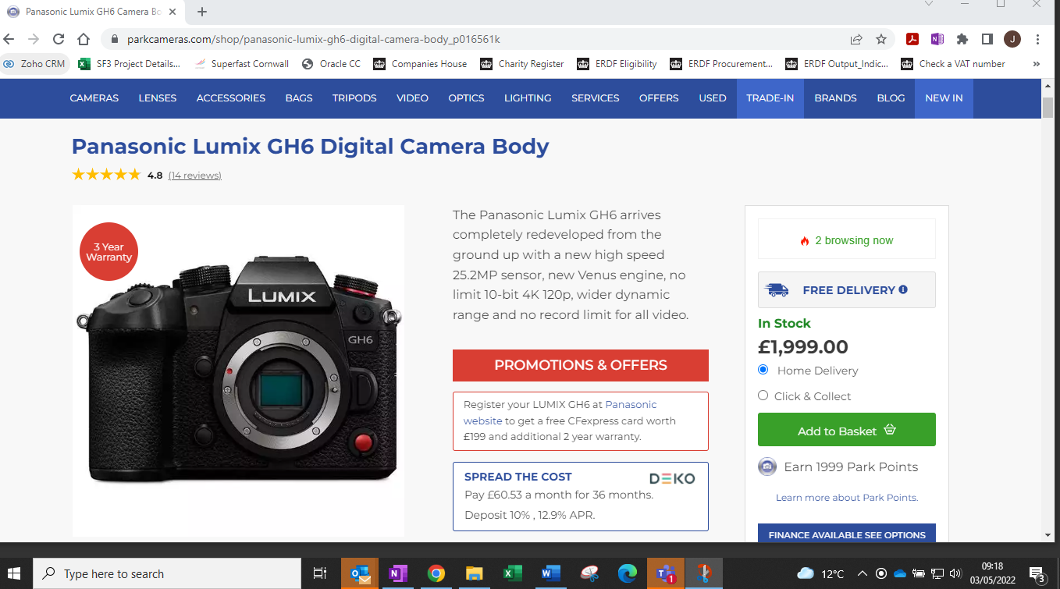

Obtaining a quote form a supplier
Where more specific work is to be completed, e.g. building a new website, you will likely to need to obtain a quote for the work.
To make sure your quote is compliant for public funding, please ensure you follow these steps:
- Email a specification of the work required to the supplier and ask for a quote by email. You may have already spoken to them to see if they can provide the service you require or you may have had some guidance from them already about what you need. It’s very important that you don’t commit to any work before a grant offer has been formally made.

- The supplier emails you back with their quote attached.

- Send Superfast Cornwall your email to the supplier and their response email with quote attached along with your application (ideally this will be as an email thread).
Step 1 Step 2 Step 3
Attach this email thread to your grant submission.
Or, if that’s tricky, you can ’forward’ the email to sf3@superfastcornwall.org
To: thebiz@applicant.co.uk
From: mysupplier@gmail.com
Date: 03/10/22
Subject: Quote for website
Attachment: Website Quote

Hi The Business
Thanks for asking us to provide a price for your website. Please see quote attached.
Kind regards
The Supplier
_____________________________
To: mysupplier@gmail.com
From: thebiz@applicant.co.uk
Date: 30/09/22
Subject: Quote for website

Hi
Please can you provide a quote for my new website?
It must be……………………………………… ………………………………………………………………………………………………………………
Many thanks
The Business

To: mysupplier@gmail.com
From: thebiz@applicant.co.uk
Date: 30/09/22
Subject: Quote for website

Hi Supplier
Please can you provide a quote for my new website?
It must be……………………………………… ………………………………………………………………………………………………………………
Many thanks
The Business

See below for an example of what information should be included in the quote
The information doesn’t need to be in the same place, but as much as possible needs to be included somewhere.
QUOTE
My Supplier
Address
Postcode
Email address
Website address

Date of quote
My Supplier

Explosive websites
to break the net

To: The Business
Address
Postcode

Dear The Business

As per your email specification, please see below details of our quote.

[Text detailing the work to be completed] £2,000

[Text detailing any additional work to be completed] £1,450

[Text detailing any additional work to be completed] £2,450

SUB-TOTAL £5,900
VAT £1,180
TOTAL £7,080

Company number 123456789 VAT number GB987654321

If your supplier is not VAT registered, they should state ‘not VAT registered’ on their quote.
If they are a sole trader and do not have a company number, please ask them to provide their UTR number.
For more information, please contact us https://www.superfastcornwall.org/contact-2/

