Do superfast broadband and tailored interventions improve use of e-health and reduce health related travel?
PhD Project funded by Superfast Cornwall and European Regional Development Fund.
PhD Student: Philip Abbott-Garner (philip.abbott-garner@plymouth.ac.uk)
Director of Studies: Professor Ray Jones (ray.jones@plymouth.ac.uk)
Second Supervisor: Professor Janet Richardson (janet.richardson@plymouth.ac.uk)

ABSTRACT
Lack of internet infrastructure, personal skills, and service provision have been identified as potential barriers to e-health but as yet there is no good evidence of the impact of interventions to improve them. This PhD aimed to assess impact on e-health uptake of three interventions (i) superfast broadband, (ii) a tailored leaflet to help participants improve personal internet skills and support, (iii) GP interventions to improve health service provision of e-health. In a cluster randomised factorial controlled trial, 1388 households from 78 postcodes were randomly selected from the 20088 Cornish postcodes and allocated to the 8 (2X2X2) arms of the study. Comparison of ‘e-health readiness’ and ‘miles travelled’ from baseline to 18 month follow-up between the 8 arms of the study, was used to assess the effects of interventions, singly and in combination.
INTRODUCTION
What is E-Health?
The term e-health is now commonly used throughout academic research and the healthcare industry. Although e-health can simply mean “using computer-based technologies in the health profession practice” actually defining the term e-health is as difficult as defining the term “internet”[1]. A review conducted in 2005[2] sought to define the contexts and settings in which the term e-health had been used. The review identified 51 unique published definitions, all of which specifically mentioned the universal themes of health and the technology involved. Six less general themes were identified (commerce, activities, stakeholders, outcomes, place and perspectives). The widespread use of the term e-health suggests that it is an important concept for which a tacit understanding of its meaning exists. Even though no precise agreed upon definition exists, a widely used and accepted definition for e-health is that of Eysenbach’s[2]. Eysenbach[3] defined the term as:
“e-health is an emerging field in the intersection of medical informatics, public health and business, referring to health services and information delivered or enhanced through the Internet and related technologies. In a broader sense, the term characterizes not only a technical development, but also a state-of-mind, a way of thinking, an attitude, and a commitment for networked, global thinking, to improve health care locally, regionally, and worldwide by using information and communication technology.”
E-health can be considered to be a ‘mother term’ which encompasses many services via the partnership of technology and health. Over recent years the internet has become an increasingly useful source for health related services including (i) seeking information from online resources, (ii) interacting with applications that support patient decision making or change health-related behaviour, (iii) viewing or contributing to medical records, (iv) seeking emotional or information support from peers, or (v) communicating with professionals online[4].
The overwhelming understanding of e-health reflects an attitude of optimism. Of the 51 definitions identified in Oh et al[2], all had positive connotations and included terms such as benefits, improvement, enhancing, efficiency, and enabling. One definition suggests that e-health allows patients and professionals to "do the previously impossible". None of the published definitions suggested that e-health could have any adverse, negative, harmful, or disadvantageous effects. With rapidly increasing technology and the public adoption of easily accessible and convenient online services, such as internet banking, the potential to utilise technology in healthcare appears endless.
However the ability for everyone to access and use this technology effectively is still an issue nationally. The Office Internet Institute[5] reported that 22% of the British population did not use the internet in 2013. This disparity, often referred to as the digital divide, has the potential to cause an inequality between users and non-users. People who stay offline do not have access to the same technological opportunities; life chances, resources, participation opportunities and development of skills and capabilities[6]. A review by Van Dijk[7] identified five inequalities referred to by the digital divide: technological, immaterial, material, social and educational. Such inequalities must be considered with regards to e-health and can serve as potential barriers to its use. These barriers include lack of physical access, experience, attitudes, confidence or self-efficacy, knowledge, and social help[4]. There is a potential risk for a divide to exist in healthcare, with digitally excluded individuals having less treatment options or potentially receiving poorer healthcare. This divide could become more apparent with the implementation of ‘Digital First’ across the NHS[8], which aims to reduce unnecessary face-to-face contact between patients and healthcare professionals by incorporating technology into these interactions. For both social justice and health service efficiency it is essential to address these inequalities and the barriers that may cause them. In view of this, it is vital that effective interventions which help reduce the digital divide, with regards to e-health, are identified and developed.
Cornwall
Cornwall is a county located in the south west of England. It has an estimated population of 532,300 spread across a large land area (3,563 km²) making it very rural area of the country with a population density of 1.5 (persons per hectare) vs the England average of 4.1[9]. It is distinct from many other rural counties because rather than having one, large central conurbation in an otherwise rural area, Cornwall shows a dispersed settlement pattern of numerous towns and villages and hamlets. Approximately 27% of the population live in the urban areas of Penzance, Camborne-Pool-Redruth, Falmouth-Penryn, Truro, Newquay, St. Austell and Bodmin. 29% live in towns and larger villages and 44% live elsewhere[10]. The population distribution is an issue for accessibility for rural areas to healthcare, transport, employment, ICT, training, community facilities and services such as shops, schools, childcare, sports and cultural activities. As a result many people depend on private vehicles to access services. Over a quarter (27%) of Cornwall’s carbon emissions are caused by transport, with car associated emissions accounting for 63%[10].
The rurality and access to services is of further concern coupled with the fact that Cornwall has an aged population, with a total of 29.7% of its population aged 60+ compared to 22.3% nationally[9]. In line with national trends, Cornwall's population is getting older as average life expectancy continues to rise. Should access not improve, potentially a large proportion of Cornwall’s population could become isolated from important services such as healthcare. Use of the internet has the possibility to significantly improve the availability of services to rural areas; arguably one of the main benefits of the internet is its capability to be accessible to anyone almost anywhere. An individual can view a wide range of health information; seek support in a forum or converse with a medical professional all without having to leave their home. However prior to the Superfast Cornwall project (introduced below), the internet infrastructure throughout the county was poor, with a maximum download speed averaging around 5-6 Mbps in the more urban areas[11] and some ‘not spot areas’ having no access to the internet. In addition the reliability was poor, meaning internet access could often fluctuate during the day.
Superfast Cornwall Project
Superfast Cornwall is a pioneering programme funded by the EU, BT and Cornwall Council aiming to provide superfast broadband infrastructure to Cornwall and the Isles of Scilly, making it arguably one of the best connected places in the world[11]. Superfast broadband is the next generation of broadband, providing a faster and more reliable service; it can deliver speeds of up to 330Mbps. Broadband delivery UK (BDUK), in line with the Ofcom definition, defines superfast broadband infrastructure as an infrastructure capable of delivering internet speeds higher than 24Mbps[12]. Introducing high speed broadband to the rural area of Cornwall is a significant engineering task costing an estimate £132 million and requiring the installation of 130,00km of fibre optic cable[11]. The programme will run until 2015, by which time fibre optic superfast broadband will have been introduced within reach of at least 95% of homes and businesses in Cornwall and the Isle of Scilly. In addition to this, Superfast Cornwall aims to provide alternative technologies, such as satellite, wireless and advanced copper to premises which are unable to be connected to the fibre optic network.
Assessing the impact of Superfast Cornwall on e-health use
Although poor internet infrastructure is recognised as a barrier to e-health, there is a lack of knowledge as to whether improving internet infrastructure alone is enough to improve the uptake of e-health services. Even with good infrastructure there is great variability in NHS provision, at present the NHS does not offer a standard e-health service throughout the country for each GP and Hospital. This means that offered e-health online services can differ based on locations and GPs in the area. This has the potential to create an inequality in health service provision based solely on geographical location. Households may have different levels of expertise, support, motivation, and economic ability to use the Internet for health. Direct assistance or simply making people aware of resources and help, may be used to try to improve uptake of e-health. Potentially identifying the needs of an individual can allow for the provision of tailored interventions to help reduce personal barriers.
With the installation of Superfast Cornwall it provided an opportunity to assess the impact which an improved internet infrastructure can have on the uptake of e-health and the reduction of health related travel. In addition to this, it provided the opportunity to identify and assess the significance the effectiveness of other interventions designed to increase e-health use, both singly and in combination, which can be conducted on a large scale and can also be repeated across the country.

METHODS
Aims and objectives
The study aimed to assess the impact of three interventions (i) improvement of physical infrastructure (Superfast Cornwall); (ii) tailored booklets to households providing information to help improve personal skills in e-health; and (iii) discussions with GP practices to encourage greater use of the Internet in health service provision.
Study Design
A pragmatic, cluster, factorial, (2x2x2) design, randomised controlled trial was used to assess the effect (singly and in combination) of each of the three interventions. Data collection was in the form of a ‘before’ (baseline survey) and ‘after’ (follow up survey) measure. Figure 1 provides a visual outline of the study.

Figure 1. CONSORT diagram of study
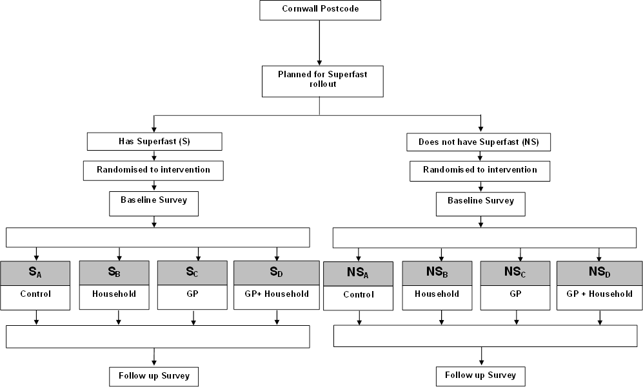

Sampling Method
A sampling method was designed to reduce potential contamination between the eight arms of the study and to also account for the rollout of Superfast Cornwall. Due to the nature of the rollout, certain postcodes within Cornwall were already superfast enabled before sampling took place. It was also not possible to accurately predict the timings of the future rollout across the county. This meant that areas of Cornwall which would remain ‘Non-superfast’ for the duration of the study could not be identified.
Intervening at practice level introduced the likelihood of contamination between intervention groups. GP Practices often serve a large geographical area; any intervention at this level would affect several postcode clusters. This meant that random selection of postcodes, without accounting for the intervention area, would likely allocate postcodes with shared practices to separate intervention groups.
The sampling method sought to reduce the likelihood of contamination by eliminating postcode clusters at the practice level. This was achieved by identifying shared practices based on geographical distances with the use of ArcGIS mapping and spatial analysis software.
As a result of this method a total of 78 postcodes were selected and randomly allocated to one of the four intervention groups within their level of superfast coverage.
Household selection
The number of households within each of the selected postcodes was obtained using the Zoopla website service[13]. The number of households per postcode ranged from 10 to 101 with an average of 62. Due to the large variability in size a total of 18 households per postcode were randomly selected. This served as an attempt to keep clusters the same size, to ensure a similar amount of both rural and urban households. Furthermore, for practical reasons, it kept the selected sample a feasible size for the design of the study.
In postcodes with less than 18 households all households were included in the sample.
Selected Sample
A total of 1388 households from 78 postcodes across Cornwall (slightly less than 78X18) where selected. With an average superfast coverage of 99% in superfast enabled postcodes. Average property values ranged from £62,638 to £515,886 with an average of 2.45 people per household. Nearest GP distances ranged from 0.05 to 5.13 miles, no two clusters shared the same GP practice.
Interventions
Intervention A. Implementation of Superfast Broadband
It was not possible for the study to allocate postcodes to receive or not receive superfast broadband. This process was under the direction of Superfast Cornwall, therefore this arm of the study was a ‘natural experiment’. Clusters were categorised into areas with or without superfast, based on the rollout at the time of sampling.
Intervention B. Household Intervention
Participants in the household intervention arm of the study received a tailored e-health information booklet in the post. Booklets were constructed based on existing documents available from national services and charities.
As the study used a cluster RCT, it was necessary to intervene at the cluster level. Therefore the entire postcode (cluster) received an e-health information booklet. This process meant that for each intervention cluster two sub-groups occurred:
1) Responders to the initial survey
2) Non-responders and households not randomly selected to complete the survey.
Responders to initial survey
Responders received a tailored e-health booklet based on their answers to the initial survey. This booklet was addressed to the individual who completed and returned the survey. This process was designed to identify the needs of an individual and then tailor an informative booklet to help address those needs. For example a non-internet user reporting that they would use the internet more for health if they could get someone to help them received a booklet showing resources in their area that assist a person in using the internet such as UK online centres. On the other hand a home internet user who reported that they lacked confidence in using the internet received information about online based internet training, such as Learn My Way. Creation of tailored booklets used a decision tree to identify which information to include in the booklet. Information was in the form of A5 ‘booklet pages’.
Non-responders and households not randomly selected to complete the survey
Where PERQ data was not available, it was not possible to identify the individual needs of the household and tailor at this level. These households received a generalised booklet constructed using the same information sources used in the personalised booklets (A5 pages). Tailoring for these households could only use geographical data, for example showing a person what is available in their area based on their postcode. The booklet was addressed to the household as opposed to an individual.
Intervention C. GP Intervention
An intervention was conducted at the GP level. This intervention involved: (i)
The researcher contacting the selected practices to arrange a meeting. This written contact explained the project and attempted to arrange a meeting to discuss use of e-health services by the practice. (ii) At this meeting GPs were given suggestions as to how they might expand from their current use of e-health services to use additional e-health services available to them and what other GPs in their area offer. (iii) A tailored booklet for the practice was produced to accompany the researcher visit. The booklet was designed to inform the practice about which e-health services were available to them, the potential benefits of adopting these services and how they might be implemented
A data log was kept describing the process of the GP intervention including responders/non-responders and the reaction to the intervention. GPs websites were assessed before and after the intervention.
Outcomes
Primary Outcomes
E-health readiness and e-health inequalities
E-health readiness includes (i) patients’ perception of e-health provision, (ii) their personal ability and confidence in using e-health, (iii) their inter-personal support, and (iv) their perception of relative costs. These were measured using a modified version of the Plymouth E-health Readiness Questionnaire (PERQ)[14]. Responses to questions in the PERQ were combined into an overall ‘readiness’ score. The standard deviation of the scores represented e-health inequalities. Therefore reductions in the standard deviation of readiness scores indicated a reduction in e-health inequalities.
Secondary Outcome
Health related miles travelled
The PERQ recorded the number of journeys and method of transport to GPs and Hospitals in the previous year. Total miles travelled was calculated by using Google Maps to estimate the driving distance to nearest GP and Hospital and then multiplying by the reported number of journeys.
Cost Analysis
The cost of interventions was estimated using data recorded on the development and implementation of household booklets and by interventions with GPs. Cost savings and expenditure by participants were estimated using response data from the initial and follow-up PERQ.
PERLIMINARY RESULTS
Detailed analysis of the results was still in progress at the time of this report (25/05/2015). The following section details some initial basic descriptive statistics from the study regarding internet use.
Response Rate
At baseline a total of 397 (29%) households responded to the PERQ. At follow-up a total of 380 (28%) households responded, 261 of these had responded to the baseline PERQ, providing a subset of individual follow through data.
Internet Use
The percentage of internet users differed marginally but not significantly at follow-up compared to baseline (82% vs 78%, $X^{2}=.317;p>0.5$). Frequency of use appeared to increase slightly with a total of 85% reported using the internet at least once a day compared to 81% at baseline however this was not significant ($X^{2}=.917;p>0.5$).
The perception of internet speed significantly higher at follow-up (Figure 2) with 90% of internet users reporting a speed that “was enough for their needs” compared to 81% at baseline ($X^{2}=10.78;p=0.005$).
Figure 2. Speed for a user’s need’s (Baseline=Green / Follow-up=Blue)
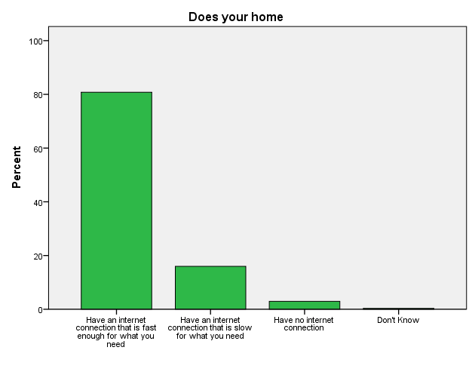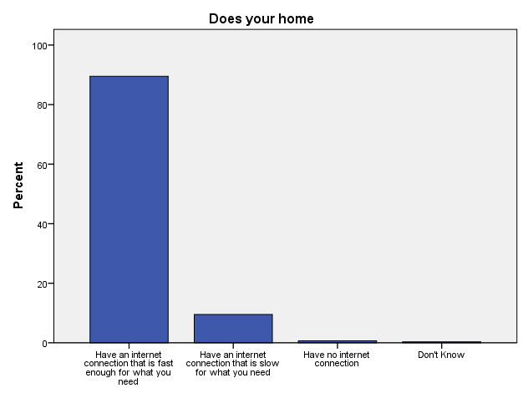

Planned Analysis
Further analysis will take place to analyse the effectiveness of the interventions at increasing the use of e-health. E-health readiness scores between intervention groups will be analysed using a form of general linear modelling.
For further information on the project please contact Philip Abbott-Garner using the details listed at the beginning of the report.

References
1. M Khalil M, Jones R. Electronic Health Services An Introduction to Theory and Application. 2007 2007;2(4)
2. Oh H, Rizo C, Enkin M, et al. What Is eHealth (3): A Systematic Review of Published Definitions. J Med Internet Res 2005;7(1):e1
3. Eysenbach G. What is e-health? J Med Internet Res 2001;3(2):e20
4. Jones RB, O'Connor A, Brelsford J, et al. Costs and difficulties of recruiting patients to provide e-health support: pilot study in one primary care trust. BMC Medical Informatics and Decision Making 2012;12(1):25
5. Dutton WH, Blank G, Groselj D. Cultures of the Internet: The Internet in Britain. Oxford Internet Survey 2013 Oxford Internet Institute 2013
6. Dutton W, Blank G. Oxford Internet Survey 2011. Next Generation Users: The Internet in Britain. University of Oxford: Oxford Internet Institute, 2011.
7. Van Dijk JA. Digital divide research, achievements and shortcomings. Poetics 2006;34(4):221-35
8. Young C, Wilkins A, Hall N. Digital First - The delivery choice for England's population. Transform LTD 2012
9. Office for National Statistics. 2011 Census: Aggregate data (England and Wales) Secondary 2011 Census: Aggregate data (England and Wales) 2011. Downloaded from: http://infuse.mimas.ac.uk. This information is licensed under the terms of the Open Government Licence [http://www.nationalarchives.gov.uk/doc/open-government-licence/version/2].
10. Director of Public Health. Cornwall and Isles of Scilly Strategy to Reduce Health Inequalities Good Health and Well Being for Everyone 2011 – 2016. Secondary Cornwall and Isles of Scilly Strategy to Reduce Health Inequalities Good Health and Well Being for Everyone 2011 – 2016 2011. https://www.cornwall.gov.uk/media/3640163/Good-Health-for-Everyone-HI-Final.pdf.
11. http://www.superfastcornwall.org/. Secondary http://www.superfastcornwall.org/ 2013. http://www.superfastcornwall.org/.
12. BDUK. Broadband Delivery Programme: Delivery Model. Department for culture, media and sport, 2011.
13. Zoopla. http://www.zoopla.co.uk/. Secondary http://www.zoopla.co.uk/ 2012. http://www.zoopla.co.uk/.
14. Jones R. Development of a Questionnaire and Cross-Sectional Survey of Patient eHealth Readiness and eHealth Inequalities. Medicine 20 2013;2(2):e9

